EIE4116 Surveillance Studies and Technologies
22077237D KONG Wing Sum Timothy
Assignment 1
Chosen Topic: Surveillance in Parking Management

Parking is something that drivers must do every day. They have to find spots to temporarily put their car and leave it to do their work. However, there are also many crimes and incidents related to parking, such as stealing and illegal parking. This can be shown from a report in 2020, highlighting that nearly 10% of property crimes occur in parking facilities [1].

These crimes may be difficult and annoying to deal with, but surveillance technology nowadays has helped in this area so much and investigating crime related to parking has been the least difficult than ever. Below I will talk more about this topic.

In the parking industry, there are a range of surveillance technologies adopted. The most famous and obvious would be the use of AI and License Plate Recognition (LPR) cameras, which is used to identify vehicles by taking a photo of its license plate and detecting the characters on the license plate, especially those that are parked in the parking lot. It involves LPR Data collection when the car enters the parking lot, and retrieving the data with an AI when the car leaves the parking lot [1].
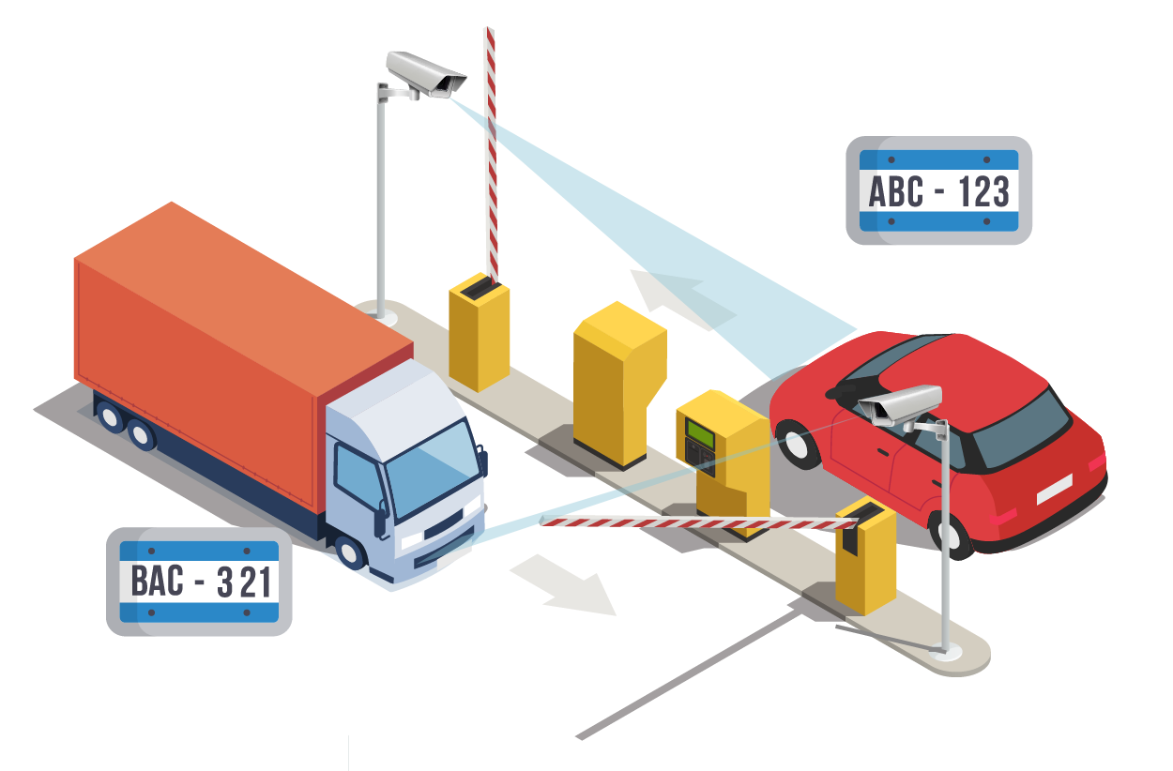
Figure 1: How LPR cameras work
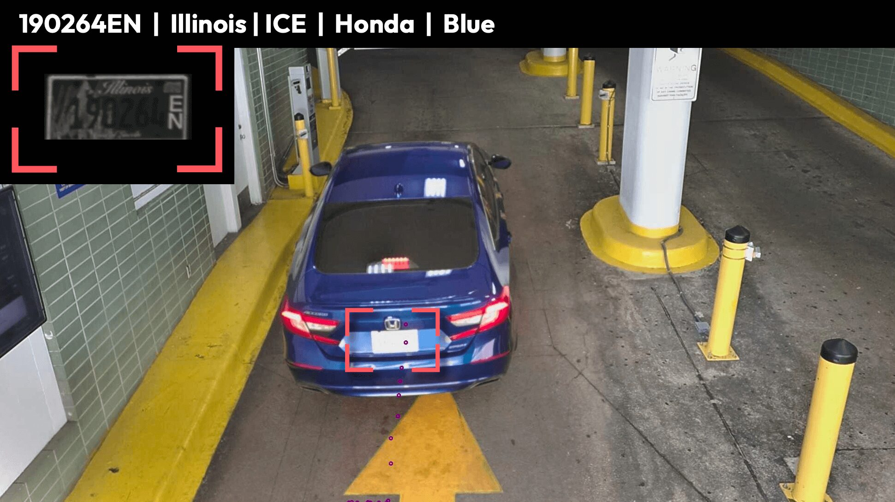
Figure 2: License Plate Recognition Cameras in action

Another technology adopted would be the use of Surveillance and Infra-red cameras, acting as sensors and for parking guidance for drivers. In some parking lots, infra-red cameras are installed above each parking spot, and shows red light when the space is occupied, while green light would show above the parking spot when its available.

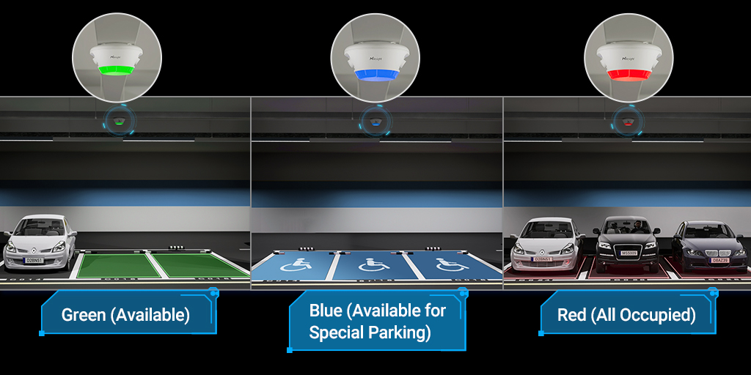
Figure 3: Infra-red cameras showing different types of lights in action

This technology would help smoothen the parking process and improve driver’s parking experience, as drivers can identify available spaces more easily. Infra-red cameras and CCTV cameras are also useful for monitoring security and the situation of a parking lot. They can also zoom in and zoom out, giving flexibility to monitor both broad areas and specific details [1].

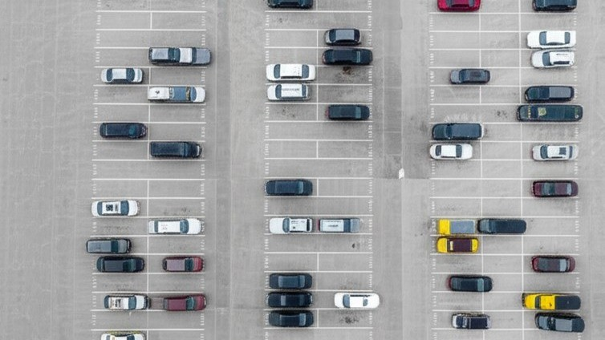
Figure 4: Use of cameras / infra-red cameras in parking lots to identify clear spaces

Automated Management Software is also used. This is because some parking lots do not have security guards, so an automated management software is needed to detect parking violations, such as drivers parking in spots that are crossed out for parking. The software is also used for managing authorized vehicles and fee payment.

But why is surveillance needed in efficient parking management? There are several reasons to it. First and most important of all is security of drivers and vehicles in the parking lot.
Knowing what cars are parked and are not parked in the parking lot is needed. In case of false authorization, meaning a car is parked without going through the proper procedures, with the use of LPR cameras and looking at the system which can store data of the number of cars parked and their parked positions, anomalies would appear, and action can thus be taken on the unauthorized car. In and out times of each car is also easier to track, and thus managing fees also become easier.

Second, it helps improve driver’s parking experience. With the use of infra-red cameras in the parking lot, available and occupied parking spots can also be detected and be shown to drivers in advance, so that drivers don’t have to find parking spots for a very long time, or pay and go in the parking lot, only to realize that it is completely occupied. With infra-red and AI cameras to detect available parking spots, and showing the driver where exactly available parking spots are would save massive amounts of time for the driver.
Third, surveillance is needed to ensure the security and safety of individuals. Cars carry high price, so they are prone to being stolen sometimes, and with cars being in a parking lot without the driver’s continuous monitoring, crimes in the parking lots are quite common.
Through surveillance, identification of potential culprits along with vehicles or weapons and methods associated with the crime can be known easily and investigating crimes would also be easier for investigators. Surveillance cameras act as evidence in case accidents happen, and acts as an intimidation tool to prevent others from committing crime in the parking lots with others’ cars, and it is evident that surveillance helps reduce crime. According to a study, it is found that surveillance cameras in parking lots help reduce crime by up to 51% in urban areas in the USA [1]. This shows that surveillance is useful in parking management.

Regarding the selection of equipment, they also have to be chosen correctly to maximize the effectiveness and efficiency of surveillance.

For example, 360 Degree Security Cameras should be used instead of regular cameras. A 360 Degree Security Camera would be able to capture a full panoramic view and would eliminate blind spots, as compared to a standard camera which can see only about 24 to 32 degrees [2]. With the use of 360 Degree Security Cameras, the entire view and situation of a parking lot of a specific area of the parking lot can be captured immediately.
Other than 360 degree cameras, cameras with high image resolution, night vision, thermal detection and with adequate storage should also be prioritized and used [2]. This is because we would want the cameras to have full effectiveness even in slightly extreme situations such as without light, when examining the details of a license plate, or to help with proper filming of crimes and incidents so that the investigation process becomes easier.
Regarding the possible uses of intelligent analysis and other privacy considerations in parking, one more thing that could potentially be added in my opinion, would be the driver identification in the parking lot.
This is to protect the car from being driven in an unauthorized manner. The idea could be, that when the car enters the parking lot, the LPR camera also recognizes the driver and its face, storing it in a system or potentially a database. Then when the driver leaves the parking lot, the system must identify the driver’s face again and authenticate its identity before the car is allowed to leave.
This may work for preventing stealing of cars in the parking lot; however, problems may rise when the driver wants others to drive on the way out of the parking lot. Since the drivers are different, the system may not recognize and the car would be unable to get out, which may hinder the driver’s parking experience, or even lead to congestion issues in the parking lot.
If this idea is passed and used however, some new privacy considerations will also rise. When collecting data while the driver drives the car into the parking lot, what data should be collected for surveillance of the driver and its car to work? Is collecting the license plate and a copy of the driver’s license needed, or enough? Is collecting the facial features, name, identity card enough, or too much for this matter? Driver’s security is indeed important, but data is also needed to be collected carefully to prevent the leakage of data due to mis-collection and storing of too much information.
All in all, surveillance has been used in parking management and has shown great success, such as through 360 degree security cameras, LPR cameras and infra-red sensors, which increases security in the parking lot, and improve driver’s parking experience. There is also room for improvements in using surveillance to help build a safer and better parking experience, and manage the parking processes, yet however the data privacy concerns that may be raised while improvements are made is something that still needs to be addressed.

References

[1] Milesight, Top Parking Lot Cameras: Features & Buying Guide, 2026 [Online].
Available: https://www.milesight.com/company/blog/parking-lot-cameras [Accessed Feb. 06, 2026]

[2] Stephan Quesada, Remote Monitoring with a 360 Degree Security Camera: No Blind Spots, No Worries, All Security Equipment, 2025 [Online]. Available: https://allsecurityequipment.com/blogs/security-cameras/360-degree-security-camera [Accessed Feb. 08, 2026]

